**MSDS LAB**

**Mini Project Report**

**On**

**HOSTEL MANAGEMENT SYSTEM**



|  | **Submitted By** |
| --- | --- |
| **Mr. N.Uma Maheshwararao** | **RegdNo:20B91A05K3** |
| **Mr. N.Yaghnesh Mani Kumar** | **RegdNo:20B91A05K9** |
| **Mr. N.Giri Sai Teja** | **RegdNo:20B91A05L1** |
| **Mr. N.Sasank** | **RegdNo:20B91A05K1** |

**Mr. M.Rajasekhar Reddy RegdNo:20B91A05J5**

**Mr. N.Venkatateswararao RegdNo:20B91A05K5**

**DEPARTMENT OF COMPUTER SCIENCE ENGINEERING S.R.K.R ENGINEERING COLLEGE(A)**

**(Affiliated to JNTU, KAKINADA)**

**BHIMAVARAM-5342041**

**(2022-2023)**

**DEPARTMENT OF COMPUTER SCIENCE AND ENGINEERING S.R.K.R. ENGINEERING COLLEGE BHIMAVARAM**



*CERTIFICATE*

**Lecturers In-Charge** **Head of the Department**

**Ch.Vinod Varma** **Dr.V.Chandra Sekhar**

**K.V.N.Valli**

Assistant professor, Head of the Department,

Department of CSE, Department of CSE,

S.R.K.R. Engineering College, S.R.K.R.Engineering College,

Bhimavaram. Bhimavaram.

**ACKNOWLEDGEMENT**

I take immense pleasure in thanking **Dr. M.Jagapathi Raju ,** beloved principal of S.R.K.R Engineering College, Bhimavaram and **Dr.V.Chandra** **Shekar,** esteemed **Head of the Department** (C.S.E), for having permittedme to carry out this software engineering mini project work.

I wish to express my deep sense of gratitude especially to my project Guide**, Sri. CH VINOD VARMA, Assistant Professor,** for his able guidance and useful suggestions, which helped me in completing the project work, in time.

Needless to mention that **Smt. K V N VALLI, Assistant Professor,** for his timely guidance in the conduct of my project work. Besides, this project made me realize the value of working together as a team and as a new experience in the working environment, which challenges me every minute.

Finally, yet importantly, I would like to express my heart full thanks to my beloved parents for their blessings, my friends/classmates for their help and wishes for the successful completion of this project.

Mr.XXXXXXXX(Regd.No)

Mr.XXXXXXXX(Regd.No)

**TABLE OF CONTENTS**

**S.No** **CONTENTS** **PageNo**

1. ABSTRACT 1

2. MODULES 2

3. SOFTWARE REQUIREMENTS 3

4. CODE 4

5. SCREENSHOTS 9

**1. ABSTRACT**

Hostel Management System is an online platform designed to manage and automate the activities of a hostel. The system helps to simplify the management process of the hostel, reduce manual work, and increase efficiency. The system provides various functionalities such as managing student information, managing room allocation, and managing student queries.

The Hostel Management System is developed using PHP and MySQL. The system has a user-friendly interface that allows hostel administrators to manage the hostel activities easily. The system provides different modules for managing different aspects of hostel management. The modules include student information, room allocation, and managing rooms.

The student information module allows the hostel administrator to maintain student records, including personal details, academic information, and hostel-related information. The room allocation module allows the administrator to assign rooms to students based on their preferences and availability.

The Hostel Management System is an efficient and cost-effective solution that saves time and effort for the hostel administration. It provides accurate and up-to-date information, reduces paperwork, and ensures transparency in the hostel's operations. The system helps to maintain a better relationship between the hostel administration, staff, and students.

Overall, the Hostel Management System is a comprehensive platform that simplifies the management process of a hostel. The system automates most of the activities of a hostel, reducing manual work and increasing efficiency.

**2. MODULES**

* **Home Page**

There are 3 different home pages

1. User Homepage

2. Hostel Manager Homepage

3. Admin Homepage

The homepage basically cointains a navigation bar which takes the user to different pages to perform different activities.

* **Login Page**

Users who have previously registered for the Hostel Room Allocation System Web

Application must login by:

1. Entering their Username/Roll No.

2. Entering their Password.

Selecting Login to advance to the next screen and begin using the application.

* **Sign Up Page**

Students who have not previously registered for the Hostel Room Allocation System Web

Application must select “Register to use the site” to access the “New User Registration” page.

There they can enter all the required details and register themselves in the portal.

* **Hostels Page**

Hostel Page is accessible only to students and they can request for room in any hostel by just clicking on the corresponding hostel link and confirming by entering their password.

* **User Profile Page**

This is again of 3 types

1. Student user profile

2. Hostel manager user profile

3. Admin user profile

For a student his user profile will also contain the hostel details and hostel manager info if he is allocated a room.

For a Hostel Manager his user profile will contains his/her personal information and Admin Information.

For a Admin only his personal information is visible in profile page.

* **Applications Received**

This tab can only be accessed by hostel manager. He can view all the applications his hostel received and allocate rooms accordingly.

* **Allocated and Empty Rooms**

Each hostel manager can look at the list of allocated rooms and empty rooms in his/her hostel by going to this tab.

* **Vacate Rooms**

Hostel Manager can vacate an allocated room by filling the student and room details in this form and clicking on “click to vacate” button.

* **Appoint/Remove Hostel Manager**

This page can only be accessed by hostel admin. He can allocate a new hostel admin or remove an existing hostel manager.

* **Students Page**

In this page the admin can see list of all the students, their details and the hostel allocated to them along with the room.

* **Contact Form**

Students can send messages to hostel manager using this form and vice versa.

* **Messages Received Page**

This page cointains messages received by the respective user(either host).

**3. SOFTWARE REQUIREMENTS**

* Windows
* Sql

**4. CODE**

**Sign Up page Front End:**

<!DOCTYPE html>

<html lang="en">

<head>

<title>SIGNUP PAGE</title>

<!-- meta tags -->

<meta charset="UTF-8" />

<meta name="viewport" content="width=device-width, initial-scale=1.0" />

<meta name="keywords" content="Art Sign Up Form Responsive Widget, Audio and Video players, Login Form Web Template, Flat Pricing Tables, Flat Drop-Downs, Sign-Up Web Templates,

Flat Web Templates, Login Sign-up Responsive Web Template, Smartphone Compatible Web Template, Free Web Designs for Nokia, Samsung, LG, Sony Ericsson, Motorola Web Design"

/>

<!-- /meta tags -->

<!-- custom style sheet -->

<link href="web/css/style.css" rel="stylesheet" type="text/css" />

<!-- /custom style sheet -->

<!-- fontawesome css -->

<link href="web/css/fontawesome-all.css" rel="stylesheet" />

<!-- /fontawesome css -->

<!-- google fonts-->

<link href="//fonts.googleapis.com/css?family=Raleway:100,100i,200,200i,300,300i,400,400i,500,500i,600,600i,700,700i,800,800i,900,900i" rel="stylesheet">

</head>

<body>

<h1>Hostel Room Allocation System</h1>

<div class=" w3l-login-form">

<h2>Sign Up Here</h2>

<form action="includes/signup.inc.php" method="POST">

<div class=" w3l-form-group">

<label>Student Roll No</label>

<div class="group">

<i class="fas fa-id-badge"></i>

<input type="text" class="form-control" name="student_roll_no" placeholder="Roll No" required="required" />

</div>

</div>

<div class=" w3l-form-group">

<label>First Name</label>

<div class="group">

<i class="fas fa-user"></i>

<input type="text" class="form-control" name="student_fname" placeholder="First Name" required="required" />

</div>

</div>

<div class=" w3l-form-group">

<label>Last Name</label>

<div class="group">

<i class="fas fa-user"></i>

<input type="text" class="form-control" name="student_lname" placeholder="Last Name" required="required" />

</div>

</div>

<div class=" w3l-form-group">

<label>Mobile No</label>

<div class="group">

<i class="fas fa-phone"></i>

<input type="text" class="form-control" name="mobile_no" placeholder="Mobile No" required="required" />

</div>

</div>

<div class=" w3l-form-group">

<label>Department</label>

<div class="group">

<i class="fas fa-graduation-cap"></i>

<input type="text" class="form-control" name="department" placeholder="Department" required="required" />

</div>

</div>

<div class=" w3l-form-group">

<label>Year of Study</label>

<div class="group">

<i class="fas fa-calendar"></i>

<input type="text" class="form-control" name="year_of_study" placeholder="Year of Study" required="required" />

</div>

</div>

<div class=" w3l-form-group">

<label>Password:</label>

<div class="group">

<i class="fas fa-unlock"></i>

<input type="password" class="form-control" name="pwd" placeholder="Password" required="required" />

</div>

</div>

<div class=" w3l-form-group">

<label>Confirm Password:</label>

<div class="group">

<i class="fas fa-unlock"></i>

<input type="password" class="form-control" name="confirmpwd" placeholder="Confirm Password" required="required" />

</div>

</div>

<button type="submit" name="signup-submit">Sign Up</button>

</form>

<p class=" w3l-register-p">Already a member?<a href="index.php" class="register"> Login</a></p>

</div>

<footer>

<p class="copyright-agileinfo"> &copy; 2023 MSDS Project. All Rights Reserved | Design by <a href="http://srkrec.edu.in/">SRKR</a></p> </footer>

</body>

</html>

**Sign Up page Backend:**

<?php

if (isset($_POST['signup-submit'])) {

require 'config.inc.php';

$roll = $_POST['student_roll_no'];

$fname = $_POST['student_fname'];

$lname = $_POST['student_lname'];

$mobile = $_POST['mobile_no'];

$dept = $_POST['department'];

$year = $_POST['year_of_study'];

$password = $_POST['pwd'];

$cnfpassword = $_POST['confirmpwd'];

if(!preg_match("/^[a-zA-Z0-9]*$/",$roll)){

header("Location: ../signup.php?error=invalidroll");

exit();

}

else if($password !== $cnfpassword){

header("Location: ../signup.php?error=passwordcheck");

exit();

}

else {

$sql = "SELECT Student_id FROM Student WHERE Student_id=?";

$stmt = mysqli_stmt_init($conn);

if(!mysqli_stmt_prepare($stmt, $sql)){

header("Location: ../signup.php?error=sqlerror");

exit();

}

else {

mysqli_stmt_bind_param($stmt, "s", $roll);

mysqli_stmt_execute($stmt);

mysqli_stmt_store_result($stmt);

$resultCheck = mysqli_stmt_num_rows($stmt);

if ($resultCheck > 0) {

header("Location: ../signup.php?error=userexists");

exit();

}

else {

$sql = "INSERT INTO Student (Student_id, Fname, Lname, Mob_no, Dept, Year_of_study, Pwd) VALUES (?, ?, ?, ?, ?, ?, ?)";

$stmt = mysqli_stmt_init($conn);

if(!mysqli_stmt_prepare($stmt, $sql)){

header("Location: ../signup.php?error=sqlerror");

exit();

}

else {

//$hashedPwd = password_hash($password, PASSWORD_DEFAULT);

mysqli_stmt_bind_param($stmt, "sssssss",$roll, $fname, $lname, $mobile, $dept, $year, $password);

mysqli_stmt_execute($stmt);

header("Location: ../index.php?signup=success");

exit();

}

}

}

}

mysqli_stmt_close($stmt);

mysqli_close($conn);

}

else {

header("Location: ../signup.php");

exit();

}

**5.SCREENSHOTS**

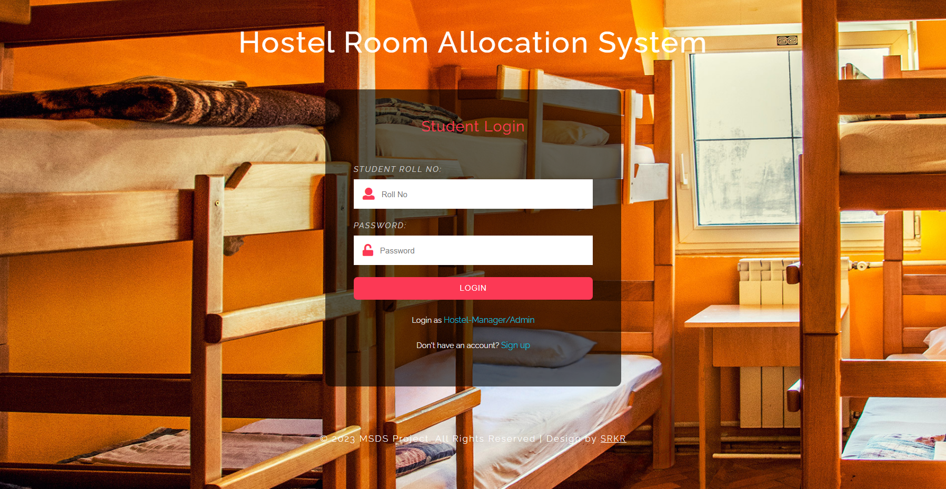

Login Page

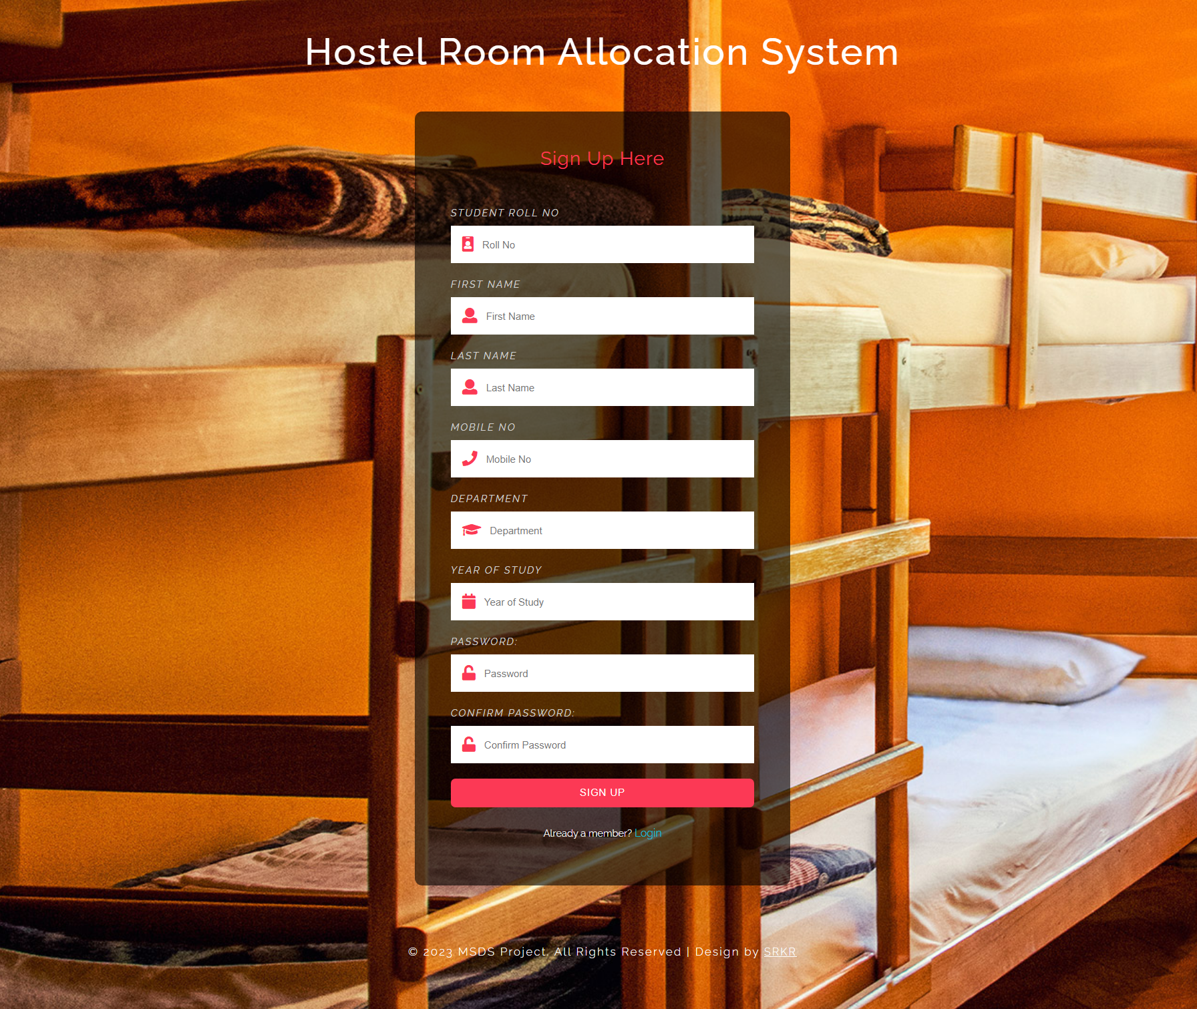

Sign Up Page

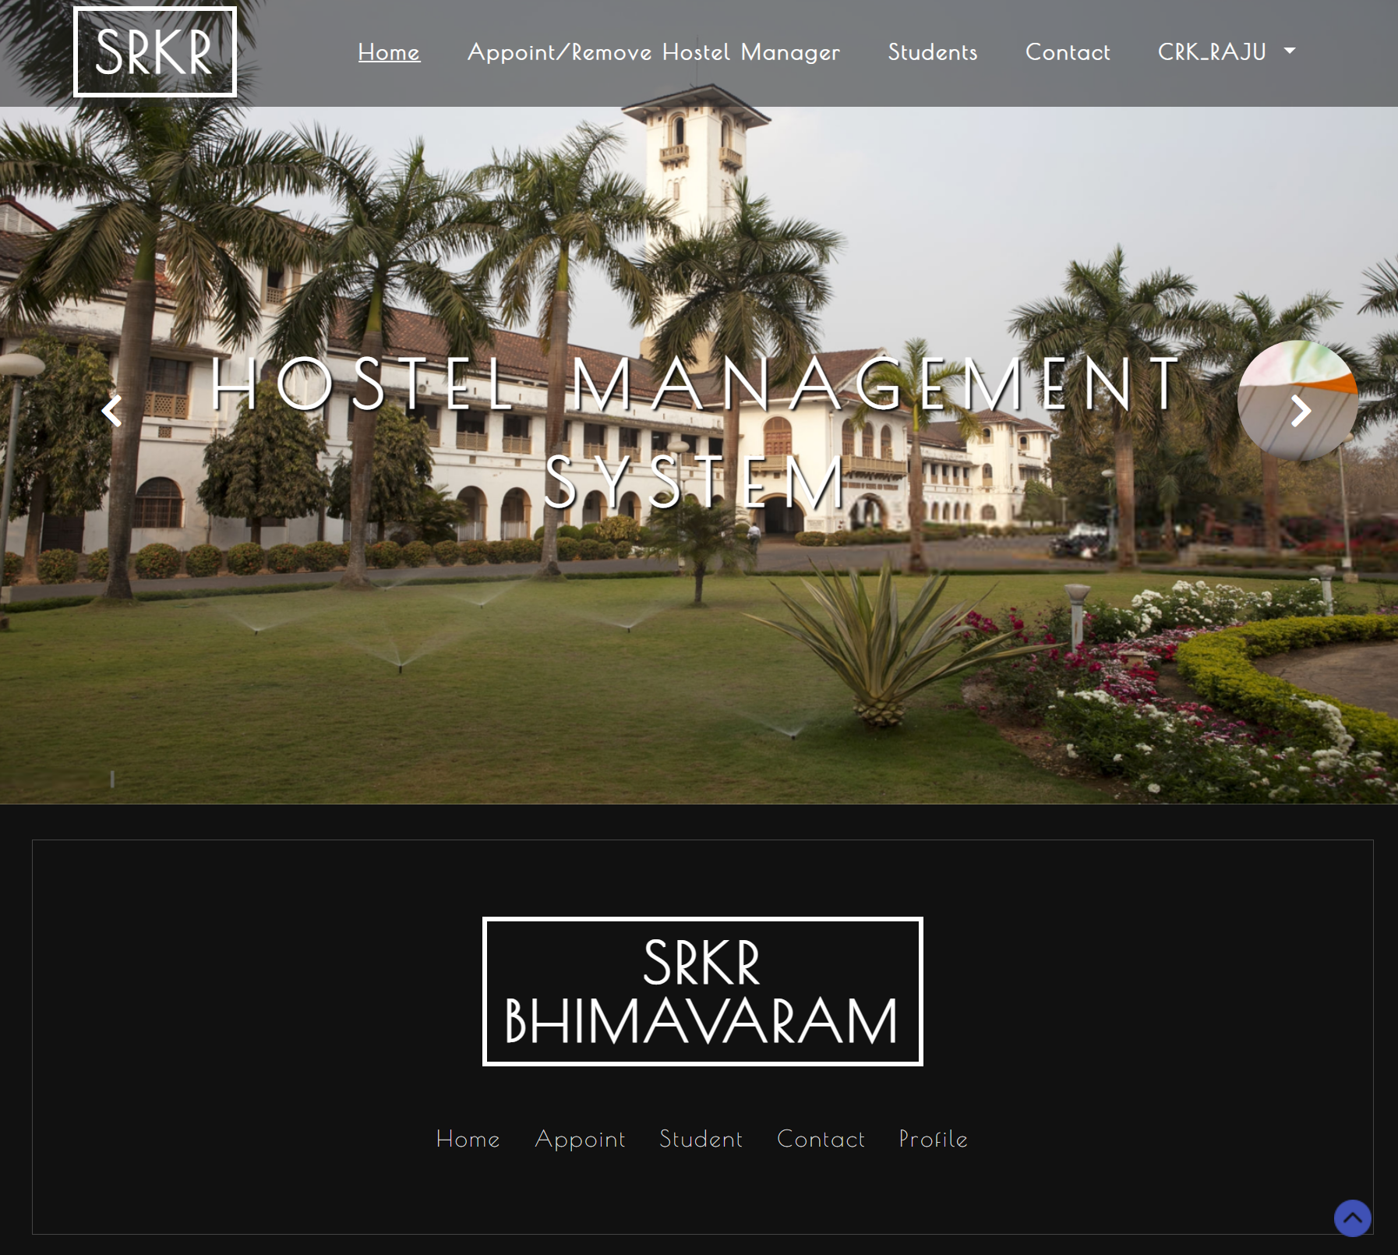

Home page (Admin Login)

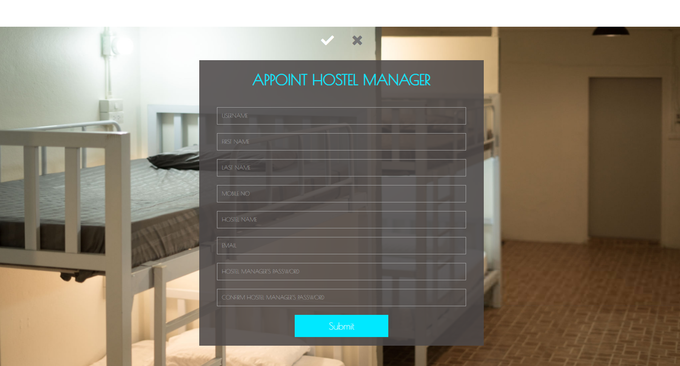

Appoint Hostel Manager Page

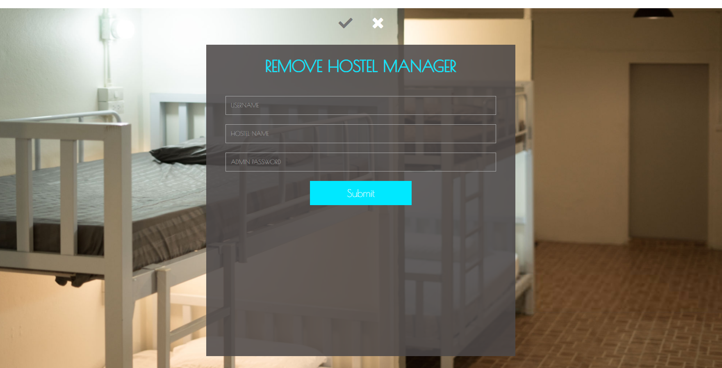

Remove Hostel Manager Page

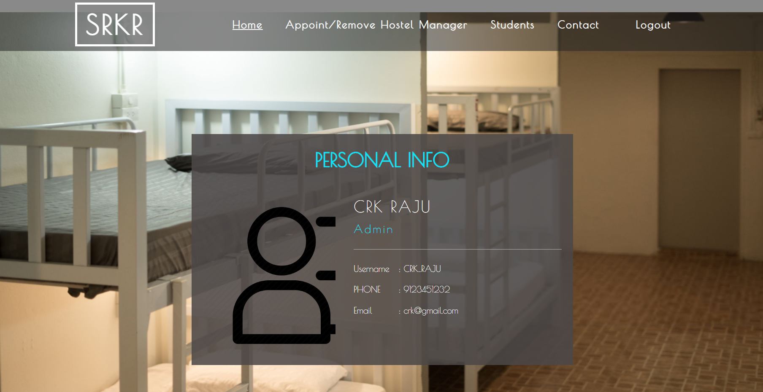

Profile Page(Admin)

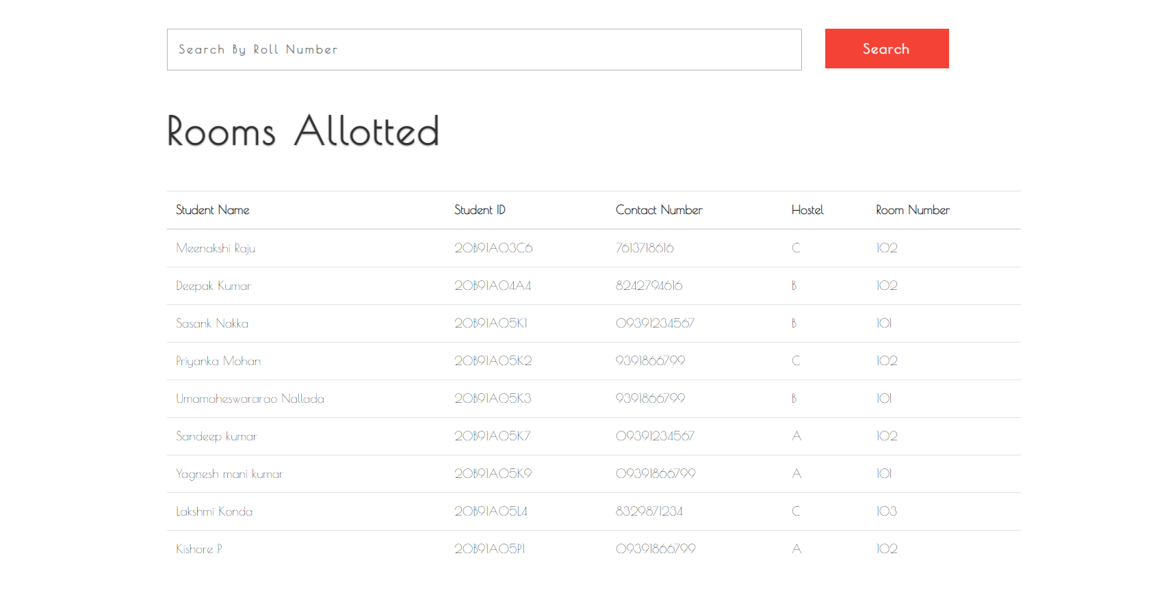

Rooms allotted Page

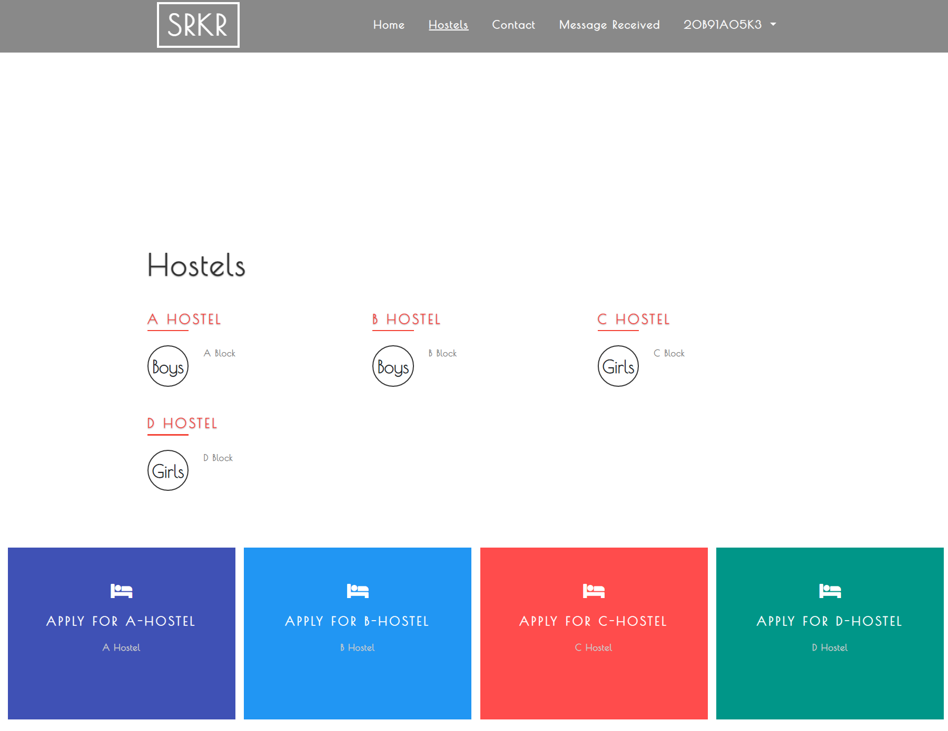

Hostels Page

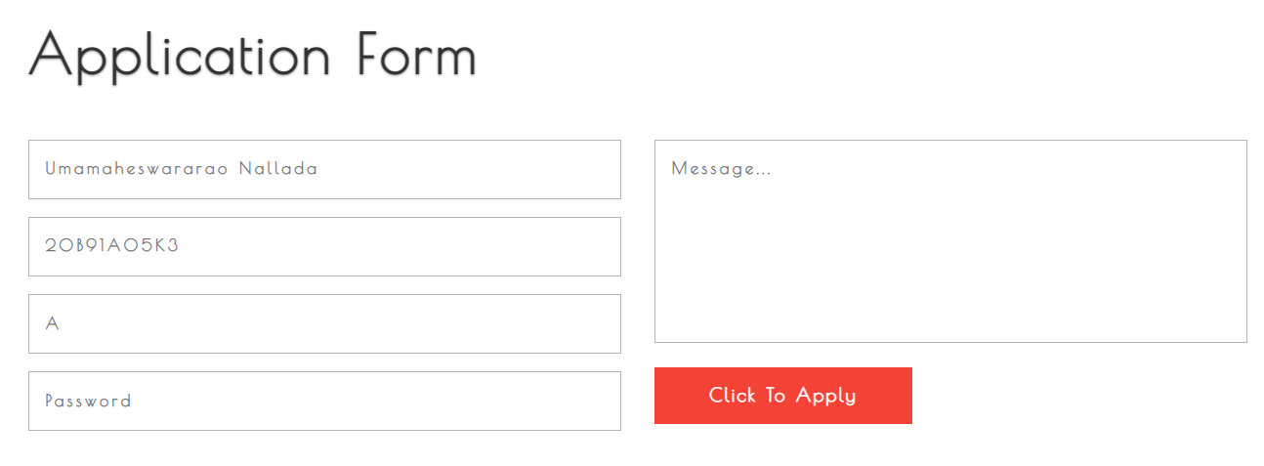

Application Form for Hostels

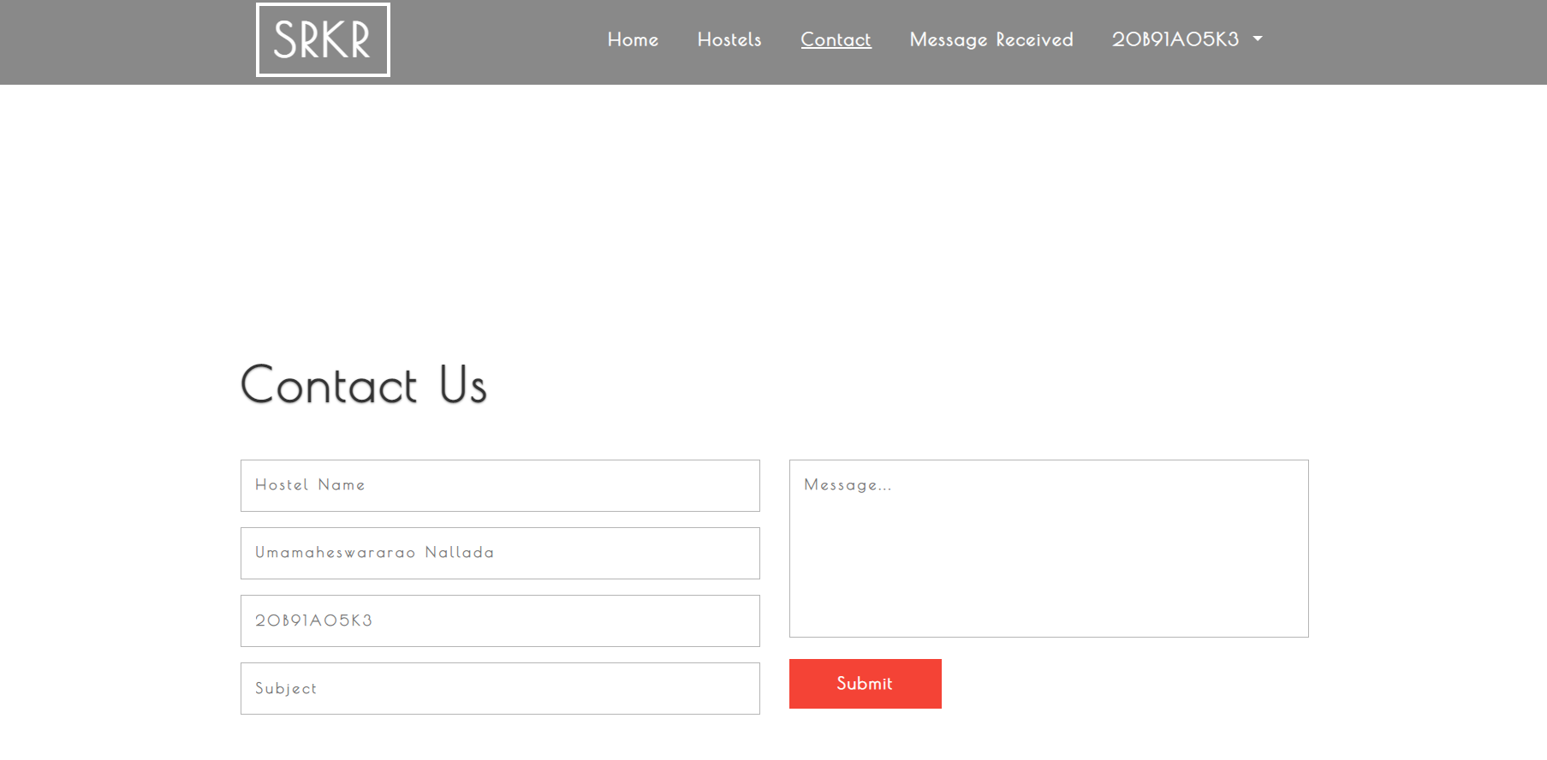

Contact us Page

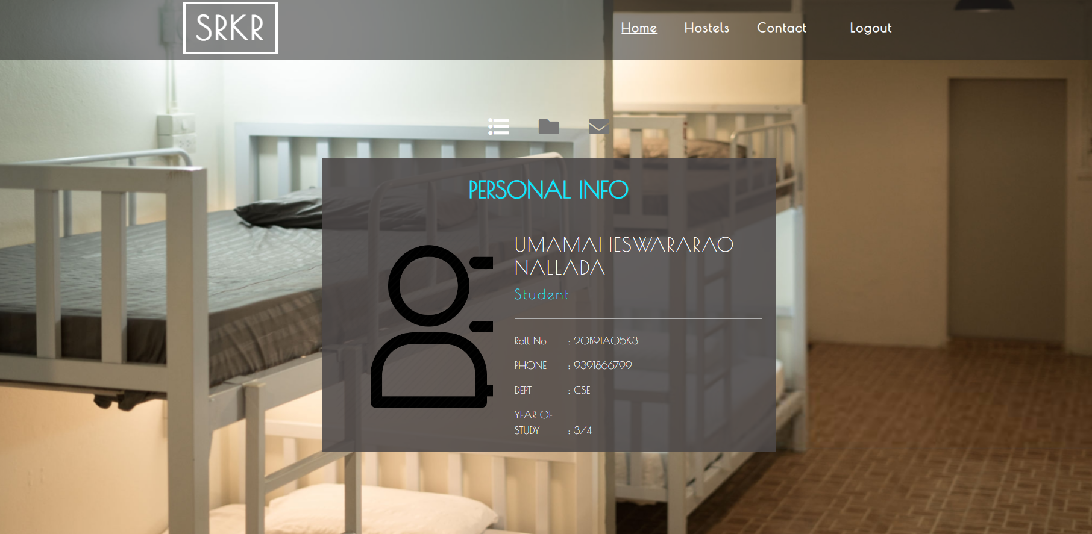

Profile Page (Student)

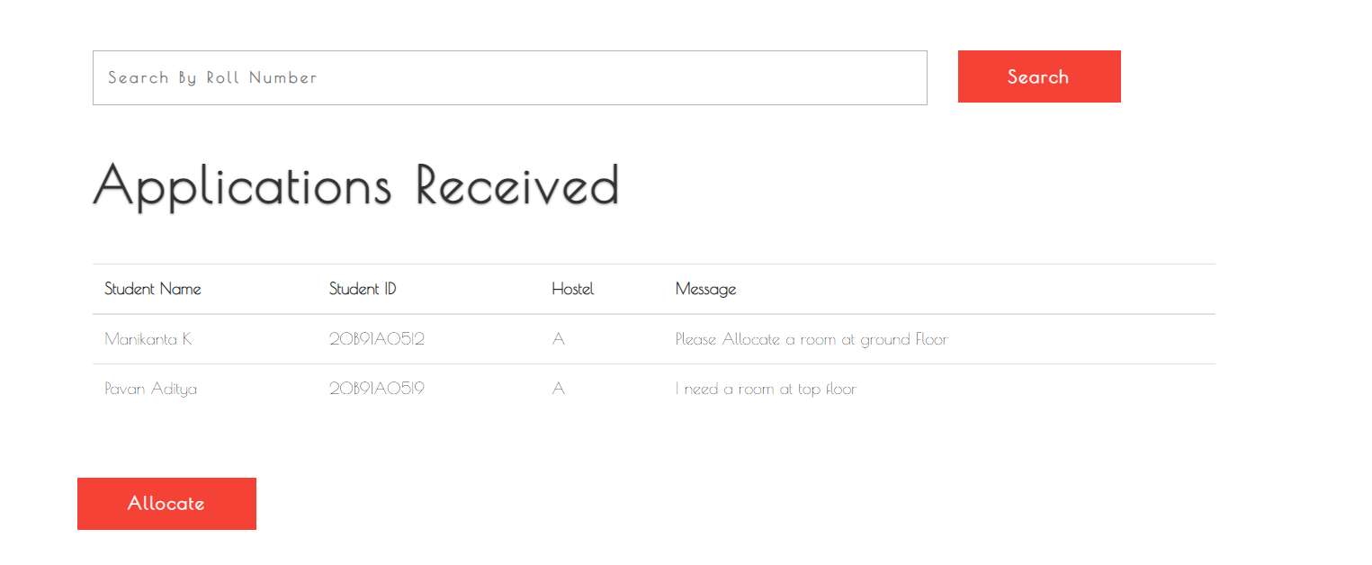

Applications Received Page

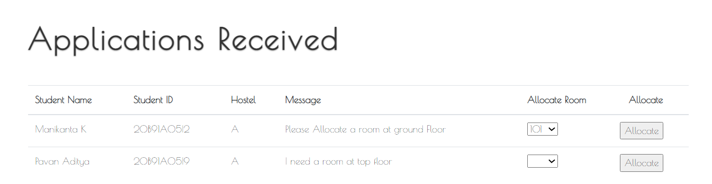

Allocate Room Page

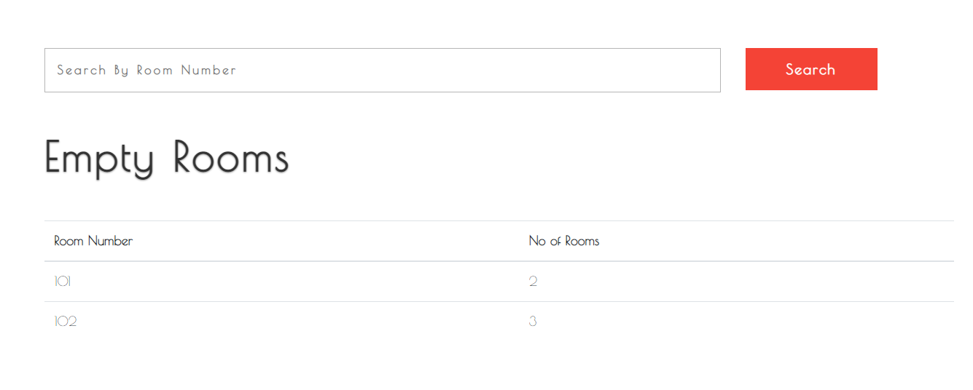

Empty Rooms page

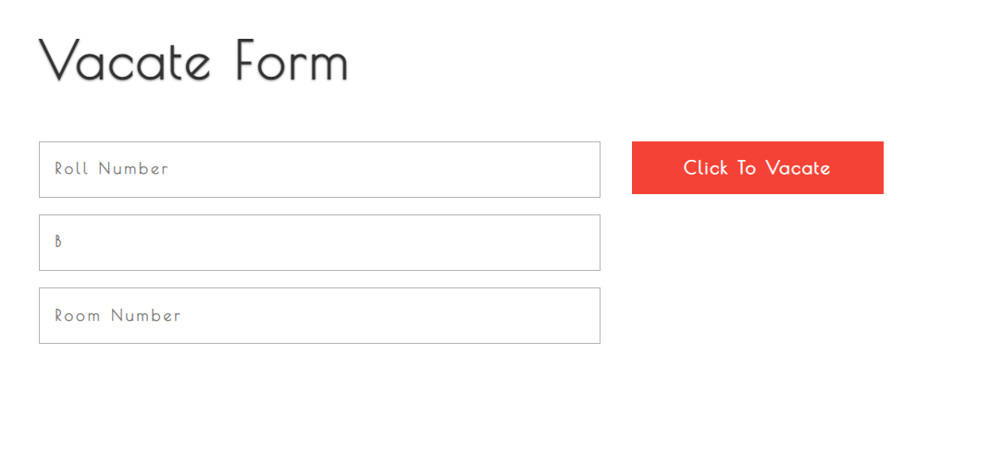

Vacate Room Page

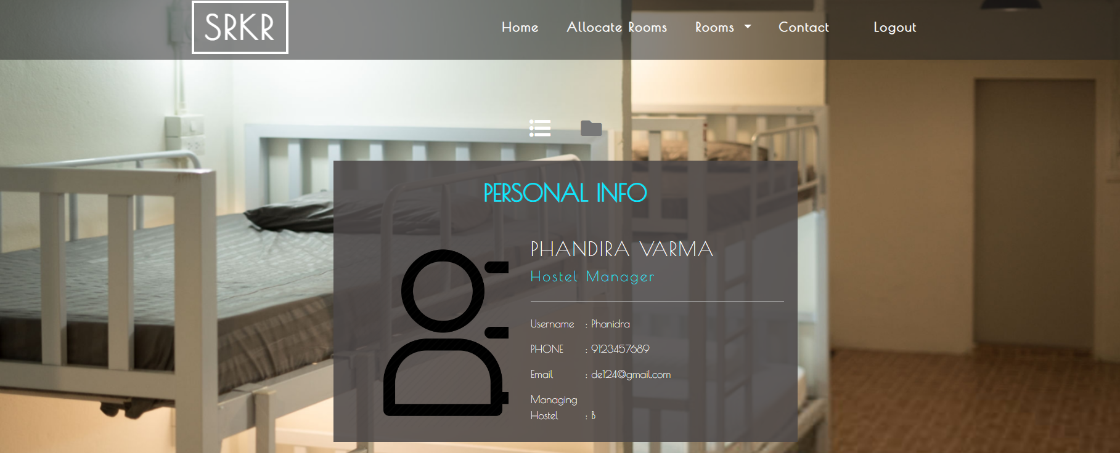

Profile Page(Hostel Manager)